1. Write a C++ program that accepts the student's name, roll number, and marks in 3 subjects. Then calculate the total marks, average, and display the final output as a marksheet.

**PROGRAM 1.**

#include<iostream>

#include<string>

using namespace std;

int main()

{

int rno,s1,s2,s3,total;

string name;

float average;

cout<<"\n Name:- ";

cin>>name;

cout<<"\n Roll No:- ";

cin>>rno;

cout<<"\n Subject 1:- ";

cin>>s1;

cout<<"\n Subject 2:- ";

cin>>s2;

cout<<"\n Subject 3:- ";

cin>>s3;

total=s1+s2+s3;

average=total*100/300;

cout<<"\n Total:- "<<total;

cout<<"\n Average:- "<<average;

return 0;

}

**OutPut:-**

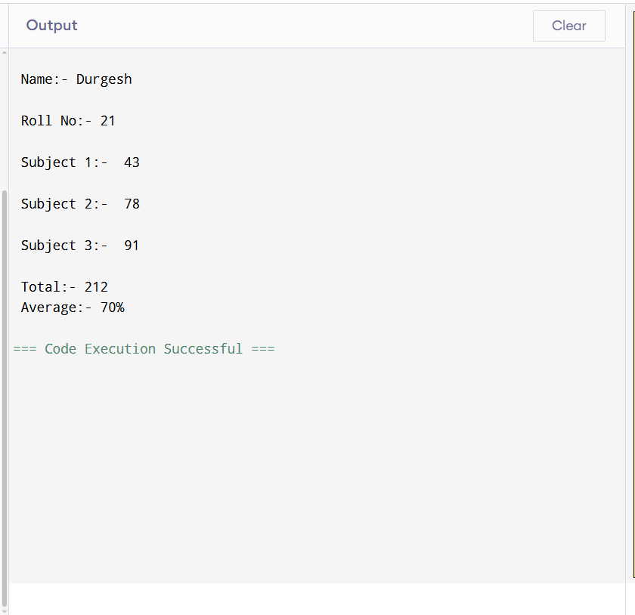

1. Write a C++ program that takes a student’s name, roll number, and marks in 5 subjects. The program should calculate the total, average, and assign a grade based on the average.

**PROGRAM 2.**

**#include <iostream>**

**#include <string>**

**using namespace std;**

**int main() {**

**string name;**

**int rollNumber,s1,s2,s3,s4,s5,total;**

**float average;**

**char grade;**

**cout << "Enter student's name: ";**

**getline(cin, name);**

**cout << "Enter roll number: ";**

**cin >> rollNumber;**

**cout<<"\n subject 1:- ";**

**cin>>s1;**

**cout<<"\n subject 2:- ";**

**cin>>s2;**

**cout<<"\n subject 3:- ";**

**cin>>s3;**

**cout<<"\n subject 4:- ";**

**cin>>s4;**

**cout<<"\n subject 5:- ";**

**cin>>s5;**

**total=s1+s2+s3+s4+s5;**

**average = total*100/500.0;**

**if (average >= 90)**

**{ grade = 'A';**

**}**

**else if (average >= 80)**

**{**

**grade = 'B';**

**}**

**else if (average >= 70)**

**{**

**grade = 'C';**

**}**

**else if (average >= 60)**

**{**

**grade = 'D';**

**}**

**else**

**{**

**grade = 'F';**

**}**

**cout << "\n Total:- " << total;**

**cout << "\n Average:- " << average;**

**cout << "\n Grade:- " << grade;**

**return 0;**

**}**

**OUTPUT :-**

